CHAdeMO

Presentation of CHAdeMO

CHAdeMO is an association whose goal is to promote a universal DC fast charging standard for electric vehicles. This objective will accelerate the deploying of infrastructure and accelerate the use of electric vehicles. Created in 2009, it is originally a consortium of Japanese companies, rapidly joined by many multinational companies. They set up many standards and technical requirements, such as the voltage, the security norms, the type of plug. The establishment of this standard can guarantee the company that their product will be compatible with the electric vehicles or the charging station market. As they don’t have to fight to impose their standard, they can focus on the innovation in their own market.

History of CHAdeMO

**2005 start of R&D project in Tepco about charging stations**

Jul 2009 Market launch of i‐MiEV (Mitsubishi) and Plug‐in Stella EV (Subaru), the first CHAdeMOcompatible EVs

Aug 2009 Foundation of CHAdeMO Association preparatory group

**Mar 2010 Inauguration of CHAdeMO Association**

Apr 2010 Publication of CHAdeMO standard specifications rev.0.9

May 2010 Start of charger certification procedure

**Dec 2010 Market launch of the first CHAdeMO compatible car Leaf (Nissan)**

Jun 2011 Launch of Connector WG

Oct 2011 Launch of Specification 1.0 WG and V2H Extension Guideline WG

Jan 2012 Publication of CHAdeMO standard specifications rev0.9.1

May 2012 CD review for IEC 61851 finalized in IEC meeting (Tokyo), CDV to be reviewed

**Sep 2012 Publication of JIS standard specification (TS D0007)**

Apr 2013 CDV status for IEC61851 approved in IEC meeting (Toronto)

May 2013 Publication of CHAdeMO standard specifications rev.1.0.0

Nov 2013 Release of V2H Guideline 1.0

Jan 2014 FDIS approval of IEC 61851‐23, 61851‐24

**Feb 2013 recognition of CHAdeMO as international standards through the norms: IEC 61851-23 for the charging system, IEC 61851-24 for communication, and IEC 62196-3 for the connector**

**Dec 2014 recognition of recognizes CHAdeMO and Combo as European official standards (EN) by CENELEC (European official standards organization)**

(2013 activity report)

Strength of the company

Market share

Currently, CHAdeMO has a leading role in the market of DC fast charging station worldwide, and more importantly in the global market of charging station. Between 2010 and 2014, 368,000 electrical vehicles were sold, among them 80% are fast chargeable. **50% of the electric vehicle cars are compatible with CHAdeMO standard**.

(final english brochure 2013)

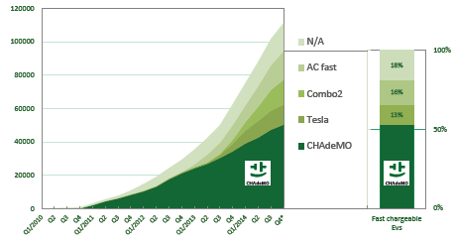

European EV sales by fast charging type (cumulative) 2010-2014

(final english brochure 2013)

CHAdeMO is clearly the leading standard for fast charging station, counting more than 7,000 chargers worldwide, especially in Japan, Europe, and the US. The other main standards are the standard combo, and Tesla. Combo is at its earliest development because only a few number of vehicles are Combo compatible for the moment, but it will increase rapidly in the future.

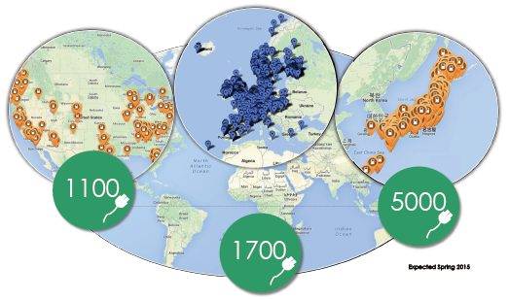

Deployment of CHAdeMO fast charger across the world (final English brochure 2013)

CHAdeMO website

In September 2012, there are 2,492 charging stations in operation, more than 70,000 compatible EVs (about 80% of all EVs).

Interest of fast charging stations

R&D of CHAdeMO

Even if the association was officially created in 2009, the R&D projects that lead to the current standard of CHAdeMO fast charging stations date back to 2005. TEPCO, the main Japanese utility, started research projects on the electric vehicle mobility, that resulted in many patents and the basis for the technology used today. The different companies of the consortium cooperate on the research for the establishment and optimization of the CHAdeMO standards. Regular Infrastructure and Technical workshops are held to share the stakeholder’s experience with the CHAdeMO standard, and to improve the technology.

Patents/ technical specifications

Using the patented technology of TEPCO developed from 2005, the technology is an automotive fast charging technology for high voltage (up to 500VDC) and high current (up to 125A). The main characteristics of the standard are:

_ the safety of user specifications

_ the connector inlet: one AC and one DC inlet to help customer make the difference

_ the communication system (CAN) : physical communication network on the vehicle between the battery and the charger control unit. It allows notably to avoid to provide energy through the inlet before it is safe, can transmit battery parameters to the charging stations (when to stop charging, target voltage, battery capacity, how the station should vary its output current).

_ output power: tradeoff between the cost of the system (charger power, connection to the grid), and the benefit (time to charge the battery): according to the manufacturer, the level is up to 50kW

_future flexibility : the system allows to go up to a current of 200A in the future, which will correspond to 100kW. Due to the superior price it will lead to, and the fact that it is not useful now because of the state of the market, the level is kept at 50kW.

_ compatibility with smart grids: it is compatible for Vehicle-to-Home systems: allows to be connected to Home Energy Management System (connection with photovoltaic panels in the roof, optimization of charge and discharge)

Consequently, the CHAdeMO standard lets possible many evolution for the future, and only focus on the critical parts of the charging station that ensure compatibility. The rest of the charger has to be developed by the manufacturer that want to tap the market. Hence it allows a healthy competition between the actors in the market.

Reference :

<http://self.gutenberg.org/articles/CHAdeMO#References>

website of Chademo

With whom do they do business

B2C/B2B companies government

CHAdeMO being a consortium, it gathers many organizations. Today, more than 341 organizations in 38 countries are represented in CHAdeMO. Nevertheless, CHAdeMO comes originally from Japan. The secretary members of the consortium are:

_ Toyota Motor Corporation

_ Nissan Motor Co., Ltd.

_ Mitsubishi Motors Corporation

_ Fuji Heavy Industries Ltd.

_ Tokyo Electric Power Company, Incorporated

_ Fuji Electric Co., Ltd.

_ Hitachi, Ltd.

_ Honda Motor Co., Ltd.

_ Panasonic Corporation

(website CHAdeMO)

The companies involved in the association can be charging stations manufacturer, automotive companies, battery manufacturer, energy utility. They all have a role to play in the electric vehicle market as well as in the charging station market.

Member list of ChaDeMo to put in Annexe

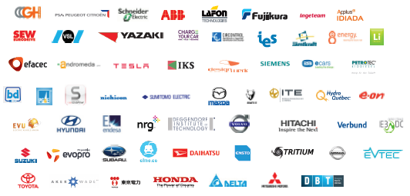

(final English brochure)

Partnership

Private/public charging stations

Strategy

Impact on the market

The use of the standard CHAdeMO has many consequences. The first one is the mutualization of the resources of many organizations to put in place the standardized technology. It guarantees that all manufacturers can get access to the market because they are sure that their product will be compatible with the electric vehicles or with the charging stations. Hence, many barriers to go to market, as well as uncertainty, are alleviated. It also means that the expense to develop the standard and the technology are beard by several entities. As a consequence, the competition between the stakeholders will be not on the framework and the laws, but on the quality of the innovation, the business model and the manufacturing skills. Indeed, the fact that many companies cooperate on the standardization does not mean they are not competitor on the market; on the contrary, their range of price and the quality of their charging station differ for the rest. There exists currently up to 50 charging station manufacturer using the CHAdeMO standard.

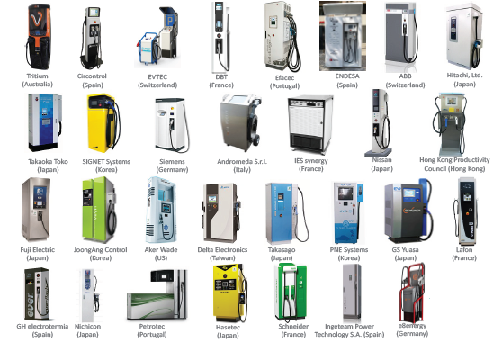

List (non exhaustive) of CHAdeMO charging stations produced by different manufacturer

(Final English brochure)

For instance, Fuji has launched the model Gen 3 DC quick charger, which is a low cost charging station with the standard CHAdeMO: the charger cost is of $25,000 (and 25kW of maximal power) compared to $40,000 for the regular CHAdeMO DC charger (50kW) for no more than 7 minutes of additional charging time. The cost of charging for a lower power is also half cheaper and will result in significant savings on the long run.

|  |  |  |  |  |  |
| --- | --- | --- | --- | --- | --- |
| Costs | Gen 3 DC Quick charger | Other DC quick charger |  | Gen 3 DC Quick charger  (over 10 years) | Other DC quick charger (over 10 years) |
|  | 25 kW | 50 kW |  | 25 kW | 50 kW |
| Charger cost | $25,000 | $40,000 |  | $25,000 | $40,000 |
| Install Cost (wiring) | $20,000 | $20,000 |  | $20,000 | $20,000 |
| Install Cost (transformer) | $700 | $4,000 |  | $700 | $4,000 |
| Install Cost (Crane Rental) | $0 | $1,000 |  | $0 | $1,000 |
|  |  |  |  |  |  |
| Operating Cost (kWh) | Same | Same |  | Same | Same |
| Demand Cost ($28/kW) | $700 | $1,400 |  | $84,000 | $168,000 |
|  |  |  |  |  |  |
| Total |  |  |  | $129,700 | $233,00 |

Table : comparison of the cost between the Gen 3 DC quick charger and other regular chargers

The other main advantage of the consortium is that it is very large and gather many different type of organizations; not only charging station manufacturer, but also automative manufacturers (Nissan, Mitsubishi, Toyota), electricity utilities (TEPCO), battery and energy companies (NEC, Hitachi, Mitsubishi, Sumitomo). This allows a great number of skills to conduct R&D, to get experience returns about the standard, to have a big weight in the standardization process in the countries and economic regions.

The philosophy of CHAdeMO is that the success of the electric vehicles market relies on the success to overcome the range anxiety effect. By promoting fast charging stations in an efficient manner, it allows the rapid development of the electric vehicle industry because of the interdependence between these two markets.

Important role of Japanese government : support of R&D projects

4 consortia in Japan from 2012: Japan Charge Network, CHAdeMO Charge Network, Nissan Leaf Zero Emissions Support, EVSS Network

The risks

Currently, another standard for fast charging stations has emerged. Originating from BMW, Volkswagen and General Motors cooperation, the standard Combo has been accepted in the European Union as another official standard. For the moment, this does not raise problems of competition for the standard with CHAdeMO, as both are official standards. However, from 2017, only Combo plug is compulsory on each charger (source : <http://www.avere-france.org/Site/Article/?article_id=5974&from_espace_adherent=0>). As most of the components are common, the extra cost for manufacturing a charging station that is compatible for the two standards does not exceed a raise of 5-10% (navigating the charging business). The European manufacturers were able to rapidly adapt and propose corresponding charging stations. The Tesla charging station will also be an actor.

The consequences are multiple. For the car manufacturers, they are thus not limited by the standards, and can only compete between electric vehicle performances. For the electric vehicle user, they could charge their vehicle at almost all charging station.

However, we can raise concern for the future. On the long run, will there be two standards or only one standard for charging stations? Nothing can indicate that there will be a reduction of standard, because it could lead to the destruction of a big share of the market. However, the decision from the European Union to make compulsory the Combo plug for fast charger, and not for CHAdeMO, can jeopardize the future development of this standard.

Still, now, to stay a competitive standard, CHAdeMO will have to attract and retain car manufacturers and convince them to adopt their standard for the plug in the vehicle. As Combo proposes a unique plug for both AC and DC changing, the risk could be that the automotive industry focuses on the Combo technology, which could finish to phase out the interest of CHAdeMO standard and lead to its disappearance. Another argument to support this is that the most successful automative brands, like the German brands, focus on Combo standard. If the customer continue to buy cars from this brand, then the CHAdeMO standard would be in fact endangered and progressively out of market.

Another potential risk is the current difficulties of TEPCO because of Fukushima nuclear accident. This major actor has cut down its expenses on the research and development in the charging station domain, handicapping the progress of the standard.

Conclusion

_ use of a standard to make every companies focus on R&D, business model -> increase of the competition in the areas that create value: many different charging stations with different price and business model

_ use of a standard remove a barrier to competition

_ the government has the power to set the rules of the market

_ limit the expenses for useless development by mutualizing the investment for the standard, that let more capital for other activities

_ at the same time, is there any risk for Japanese infrastructure ?...

CHAdeMO should get ready for the war to come about the standardization of the fast charging station. From a leading role in the domain, some decisions and competitors could endanger the bright future it was predestined to. What makes this giant having feets of clay?

CHAdeMO is an association promoting a standard for the DC fast charging station. Its aims at establishing a dense network of fast charging station worldwide, because it considers that it is the only way to overcome the range anxiety effect, this fear of the drivers to run out of battery in a desert of charging station. With a technology permitting to charge every electric vehicle up to 80% of its battery capacity in 30 minutes, it recommends, according to the Japanese origin of its name, to drink a cup of tea meanwhile.

Gathering today more than 341 companies from more than 38 countries, its early development was pretty fast. Indeed, this champion was originally a consortium of all the best Japanese industry that could have a role to play in the electric vehicle industry:TEPCO, that was the first to start a R&D program on charging station in 2005; but also automotive companies like Toyota and Nissan, or battery and energy companies. These companies founded the association in 2009. In the end of 2010, the first electric vehicle compatible with the standard was launched in the market: the Nissan Leaf.

Quickly, things accelerated. Backed by the Japanese government, that gave subsidies for R&D for the performant companies, a dense network of charging stations emerged in Japan; then was the turn of Europe and the United States. Nowadays, more than 7,000 CHAdeMO charging stations are connected to the grid. The sale of electric vehicle compatible to CHAdeMO standard has also risen sharply: between 2010 and 2014, 368,000 electrical vehicles were sold, among them 80% are fast chargeable. **50% of the electric vehicle car market is compatible with CHAdeMO standard**.

At the same time, CHAdeMO companies mutualize their resources to impose their standard to the market, gathering security issues, a maximal voltage of 50kW, communication channels between the battery and the charger, leaving also areas of improvement with the development of the technology. The specifications are improved every year through various workshops. Nowadays, many car manufacturers still produce cars that can use CHAdeMO plug. These efforts finally resulted in the recognition of CHAdeMO as an international standard and as a European standard.

These outcomes are good for all the companies participating in the CHAdeMO association: they get a guarantee that they technology will be used in the following years. Instead of fighting to impose their standard, which would be a barrier to the rapid development of the market, they need to convince the consumer in terms of technical performance and price. The obstacles to the competition being alleviated, the race for innovation is very fierce: more than 50 companies actually manufacture different DC charging stations with the standard CHAdeMO, and the technology is improving at a fast pace. The company Fuji recently launched in the market a low cost charger: by lowering the voltage to 20kW, it makes the usage price go down with a charging time that does not exceed 7 extra minutes. Inevitably, this will pull the prices of the market down.

The Western car manufacturers, outpaced in this first round, tried to win the second by establishing a competitive standard, Combo. Developed by the biggest automotive manufacturers, such as BMW, Volkswagen, or General Motors, the initiative is an attempt to catch up the lost time against the Japanese corporations. Although there is still a few cars compatible with Combo charger, they managed to make Combo certified as a standard in the US and in Europe; what’s more, all public DC fast charging station in Europe should necessarily be equipped with a Combo plug from 2017, which is not the case for CHAdeMO…

Still, due to the fact that many components are common between the two standards, many European manufacturers responded by proposing two plugs in their charging station: one Combo, and one CHAdeMO, with an extra cost lower than 5 to 10% of the charger price. Consequently, every major stakeholder in the European market finds its interest until now: the companies following one of the two standards because they will be well represented in the network; the European Union because of the healthy competition environment it managed to provide by permitting the two standards to coexist; and the consumer that can buy an electric vehicle without the fear that the standard they chose will be out of the market the next year.

Thanks to the massive presence of CHAdeMO in the market, both in terms of already existing infrastructure and wide range of compatible car, it could not be ignored and has still an important role to play. But can we assess the same within 10 years? When the biggest Western manufacturers will catch up and propose competitive electric vehicles, it is not guaranteed that the consumer will not massively shift to their favorite trademark at the time of petrol cars, which would be more German than Japanese cars. If we add the fact that the Combo charger network will be necessarily well developed due to the European commission decision, it is possible that CHAdeMO will be phased out. What’s more, the Fukushima accident has slowed down the dynamism of TEPCO, the leading company in CHAdeMO’s standard, in the research and publication of new patents in the industry.

Finally, this case shows that the battle of standardization is not over in the market of charging station. Even if CHAdeMO was by far the fastest to impose its standard, and did it in a very organized way, the pie is foreseen to be too large for other car manufacturers to ignore it. The coexistence of these two standards makes the competition environment in the European Union quite healthy for the moment, but anyone that wants to tap the market should be aware of the danger to put all its eggs in one basket. Although CHAdeMO is leading the race, the emergence of Combo, and even Tesla supercharger, is such that all the options should be kept open for the moment. On the contrary, it is wiser to focus on the business model and the competition on the price and the governments’ subsidies to thrive.

References

Avere-france.org, (2015). *CHAdeMO parmi les standards européens de charge rapide DC*. [online] Available at: http://www.avere-france.org/Site/Article/?article_id=5974&from_espace_adherent=0 [Accessed 13 May 2015].

CHAdeMO brochure. (2015). 1st ed. [ebook] CHAdeMO, pp.2,3,5,6. Available at: http://www.chademo.com/wp/wp-content/uploads/2015/03/20150313FinalEnglishBrochure.pdf [Accessed 13 May 2015].

Chademo.com, (2015). *CHAdeMO Association*. [online] Available at: http://www.chademo.com [Accessed 13 May 2015].

Charger installation, legislation and CHAdeMO activities in Europe. (2014). 1st ed. [ebook] CHAdeMO, p.7. Available at: http://www.chademo.com/wp/wp-content/uploads/2014/05/CHAdeMOEuropeActivities_EN.pdf [Accessed 13 May 2015].

DC Quick charging - FEA Comparison Study (25kW vs 50kW). (2012). 1st ed. [ebook] Fuji Electric Corp., p.5. Available at: http://www.americas.fujielectric.com/sites/default/files/DC%20Quick%20Charging%20-%20FEA%20Comparison%20Study%20%20(25kW%20vs%20%2050kW)%207-3-12.pdf [Accessed 13 May 2015].

Member list. (2015). 1st ed. [ebook] CHAdeMO. Available at: http://www.chademo.com/pdf/memberlist.pdf [Accessed 13 May 2015].

Self.gutenberg.org, (n.d.). *CHAdeMO*. [online] Available at: http://self.gutenberg.org/articles/CHAdeMO#References [Accessed 13 May 2015].

Weiller, C. and Neely, A. (2014). Business Models for Electric Vehicles: Lessons from the Japanese EV Ecosystem. *Lecture Notes in Mobility, Electric Vehicle Business Models*, pp.199,200.